# Deploy the custom fior apps to the build work zone/Access through the tile.

## Ref Links:

<https://youtu.be/iUSKxtBAP-M>

## Configuration for Fiori in build work zone:

1. Create the Fiori Apps and deploy it
   1. Once Fiori App ready, we will deploy the apps to BTP.
   2. BTP means- specifically html5 application repository
   3. This repository act like a storage space for all the deployed apps in BTP. Weather Ui5 Fiori elements app/ Html5 based apps.
   4. Once deployed in BTP(Html5 app repository).
2. Content explorer.
   1. Check the html5 repository automatically discover the newly newly deployed apps.
   2. This code includes application build on ui5/fiori elements/ on premise application that are connected through the runtime destination.
      1. On premise apps also there in sap build work zone.
      2. Content explorer- continuously check the html apps respository. Seems to like the scanner inside your btp sub account.
   3. Once the application available in content explorer, you can add it to catalog and Group.
3. Group & Catalog:
   1. Group- defines how those apps organized on the screen.
   2. Catalog – defines which application is available.
   3. Catalog -as the menu
   4. Group- as the visible tile on your launchpad screen.
4. BTP site/ Fiori Launchpad: you can have multiple apps in a single group and multiple groups in a single catalog. There after we have to configure the fiori launchpad in a build work zone.
   1. Build work zone is a site- that is configuration of a site, in this step groups and catalogs are pulled into your site.
   2. So this entire your group and all the catalogues and inside that groups you are putting your UI5 apps.
      1. This is group1- consists of 2 ui5 apps.
      2. Group2- consists of 2/3 ui apps.
   3. This group1 and group2 present in site1, we have to create the site1 in build work zone.
   4. Groups and catalogues are pulled into a site.
5. Now use has launchpad where they can see and access your deployed application.
6. Assignment of the role :Authorization: we create a custom role and assign the relevant app and the catalog to its role. Then it is assign the role to user or the business user in btp cockpit via is IAS-identity authentication service ,only user have this role then only able to see the tiles or access the application in fiori launchpad.

## Practical:

1. BTP Details

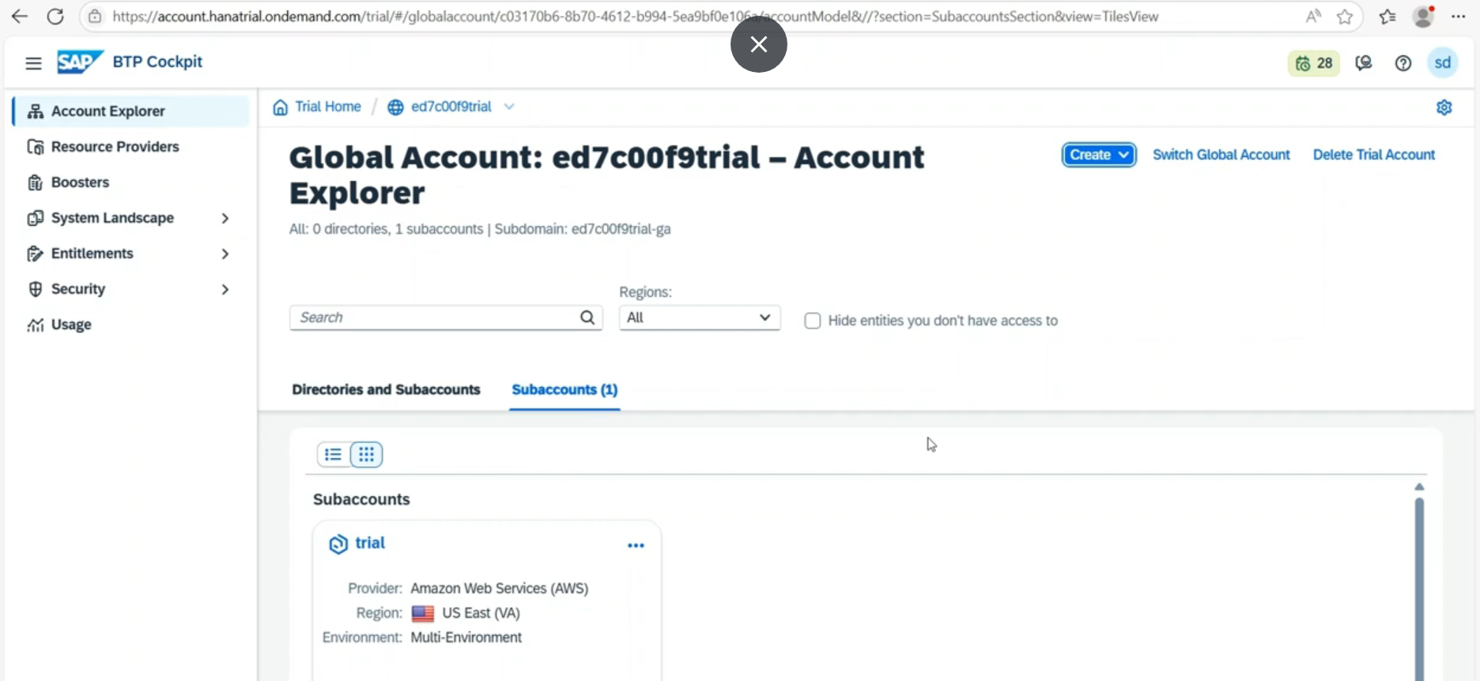

Open the trial account.- Sub account 🡪

1. Click on html5 applications
   1. 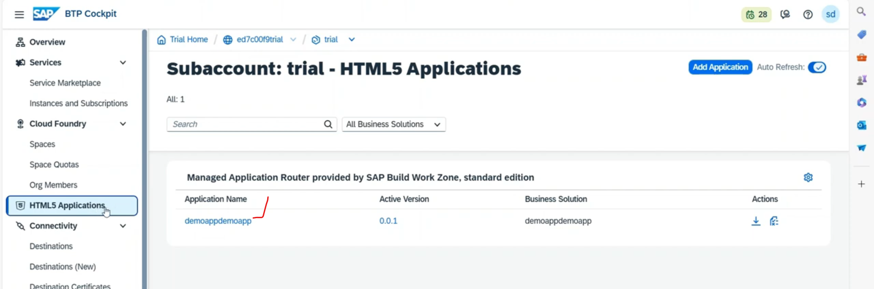
   2. Demoappdemoapp 🡪 from BAS it has deployed and stored html5 applications repository.
   3. Once click on this it will redirect to the build work zone and load the page and preview available.

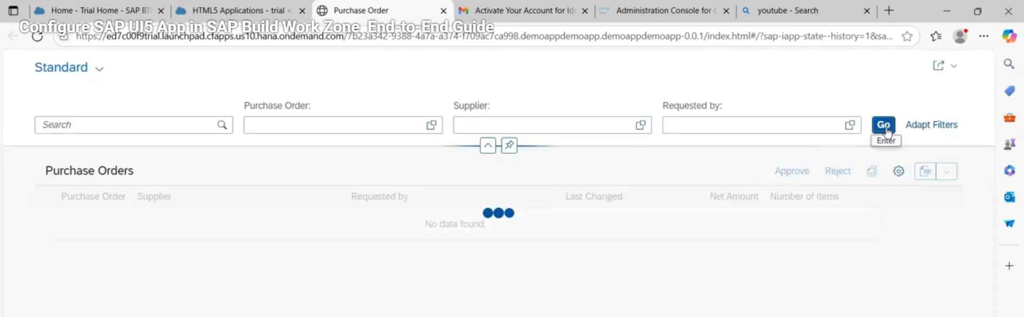

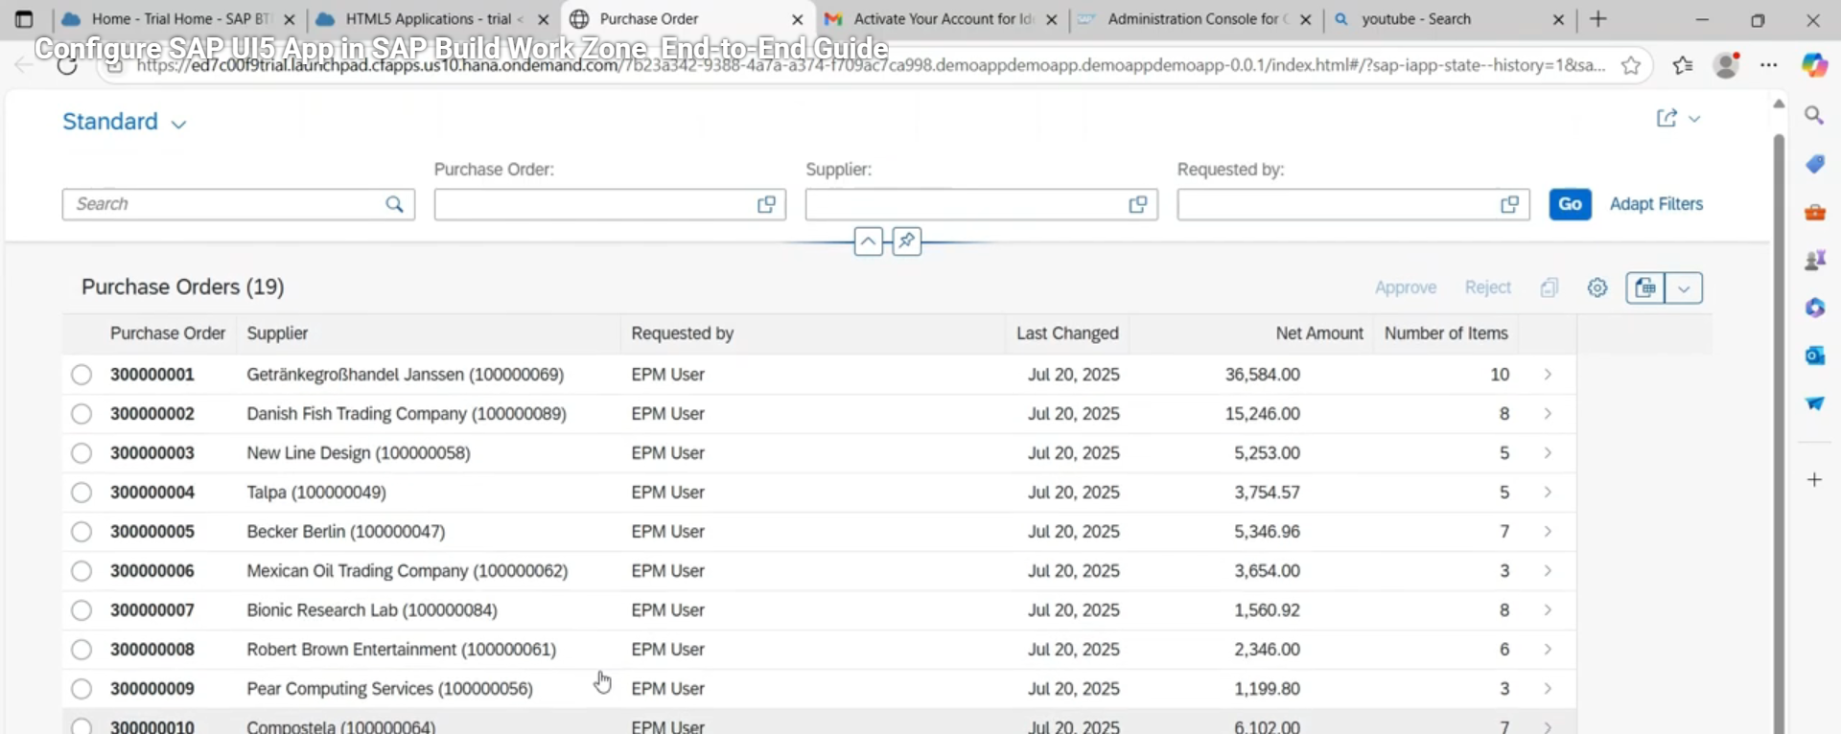

1. instance and subscriptions 🡪 already build work zone subscribed.

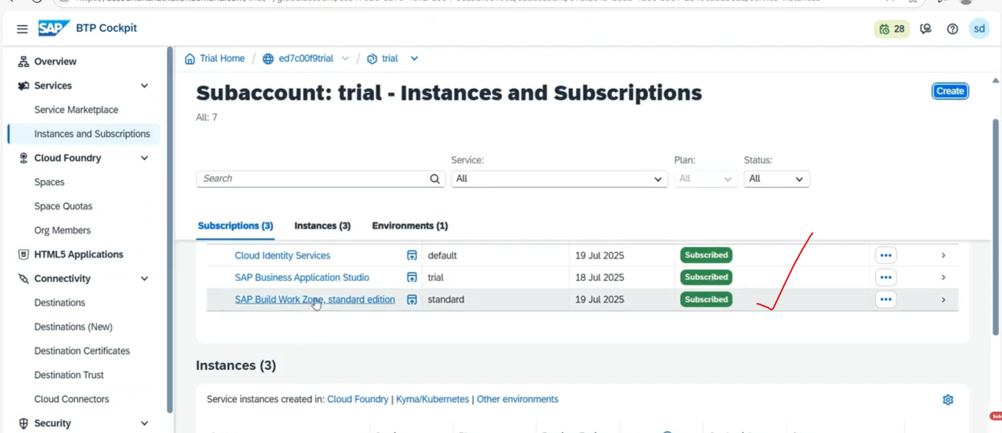

Click on build workzone . it will redirect to another page

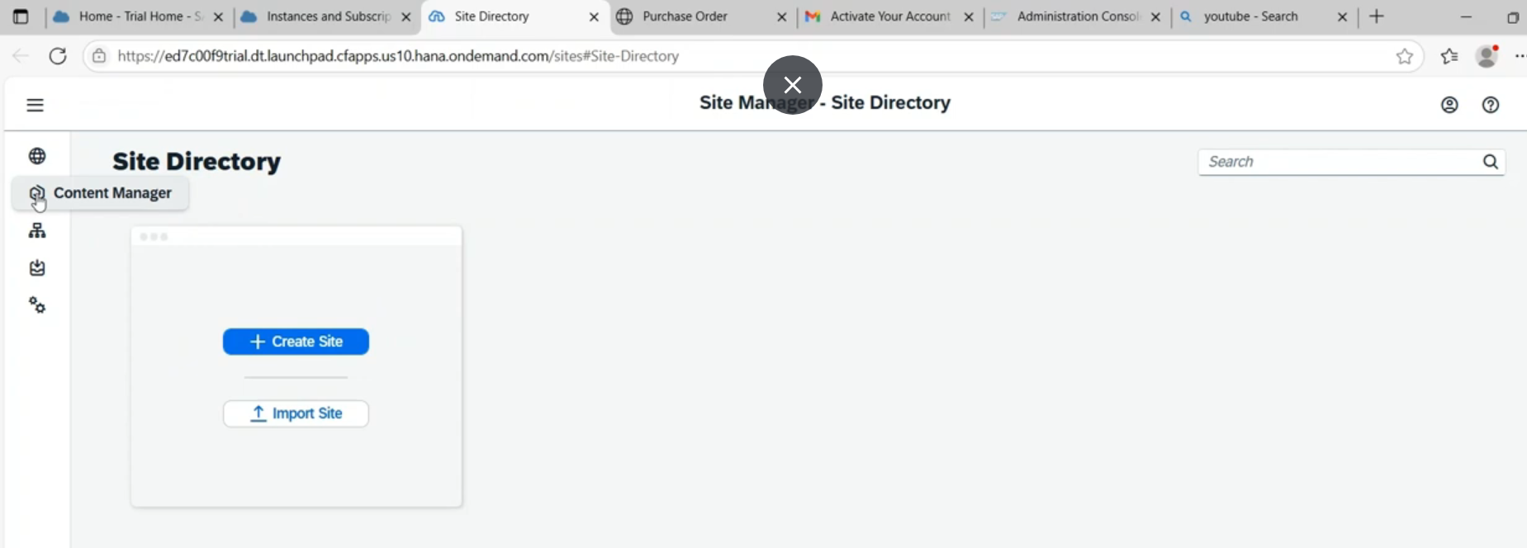

Go to channel manager:

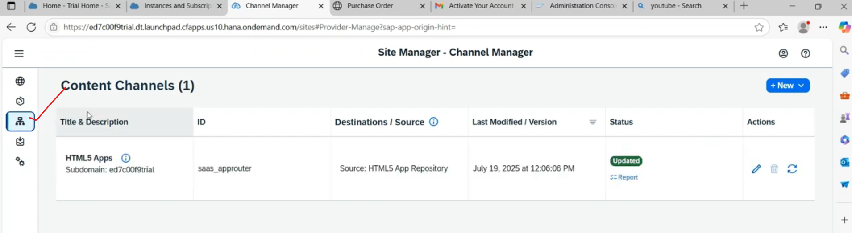

By default : one channel is there- that is html5 apps.

Here html5 apps is the channel content name.

Application which we deployed from sap-bas(business application studio) into cloud foundry and these goes and sit into the html5 repository.

Since we deployed the apps and these go and sit in html5 apps- content channel

1. update the channel first. 🡪when click on refresh button for each channel.

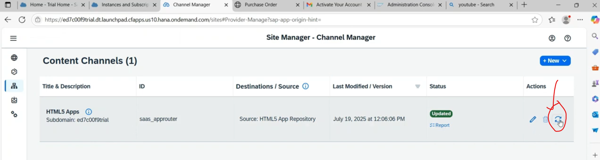

Once updated with the latest apps.

Go to content manager.

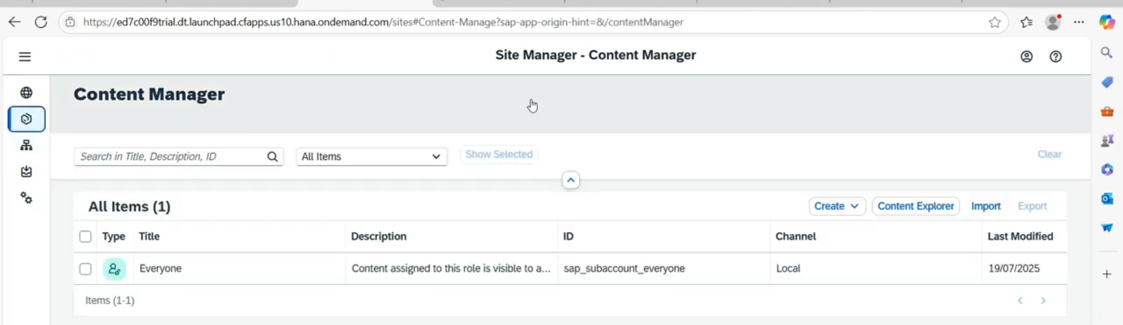

Here : everyone – is actually role name, if I am putting any applications and assign the role- everyone –then you can easily access our apps.

* 1. We have to identities the application name -purchase order.
  2. Go to content explorer under the content manager and click that.

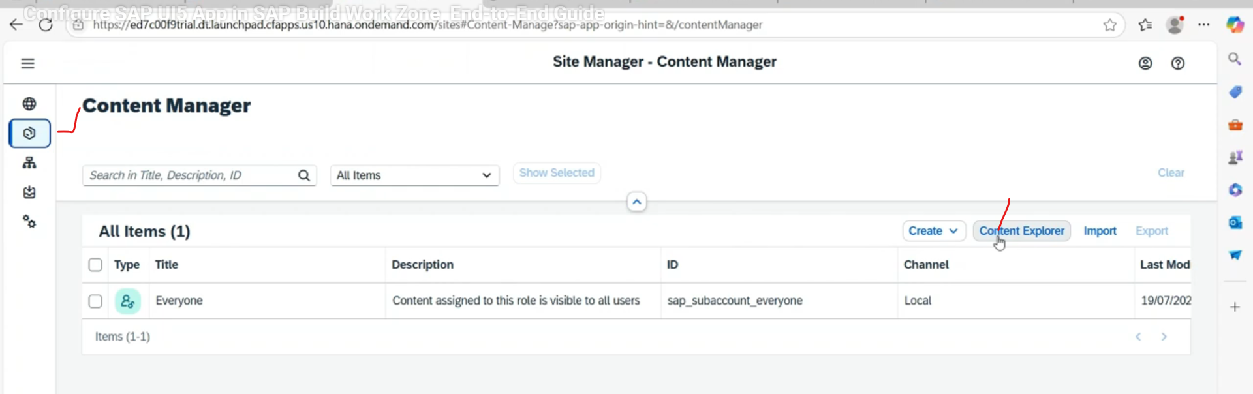

* 1. Under content explorer – we have to select the channel. Our channel is HTML5 Apps.

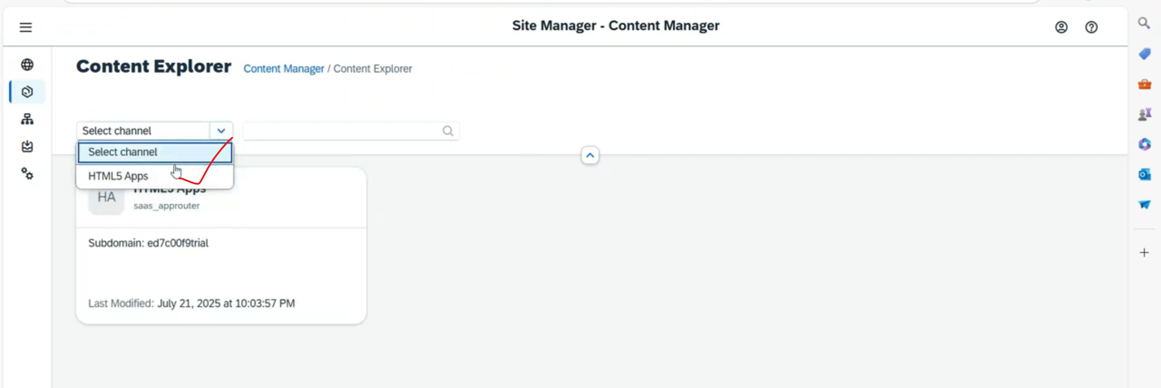

In this html5 apps- channel- all applications are available, need to bind the specific application name- purchase order and select it and click on add

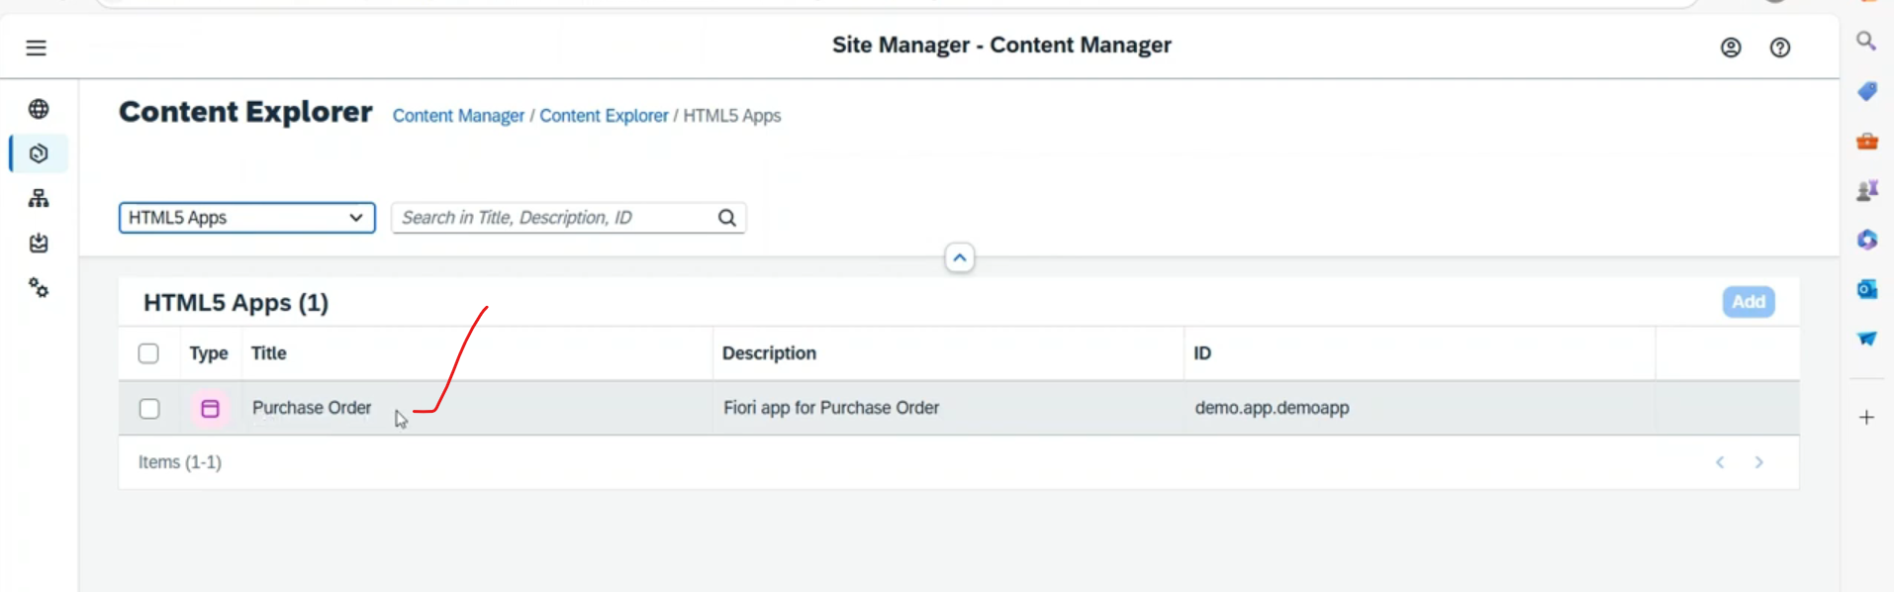

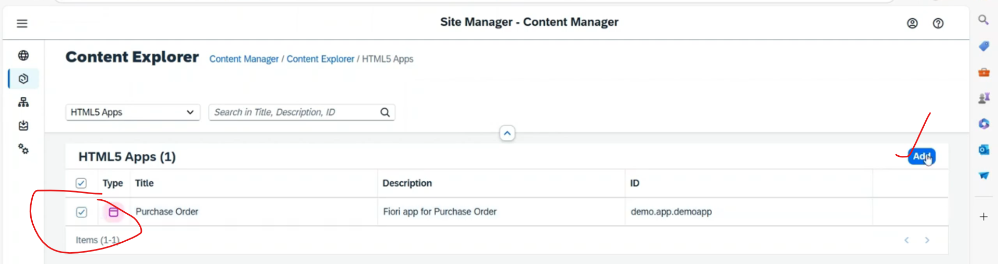

Once add- get the message as – content items added to subaccount/content manager successfully.

Verify it - Now again going to the content manager.

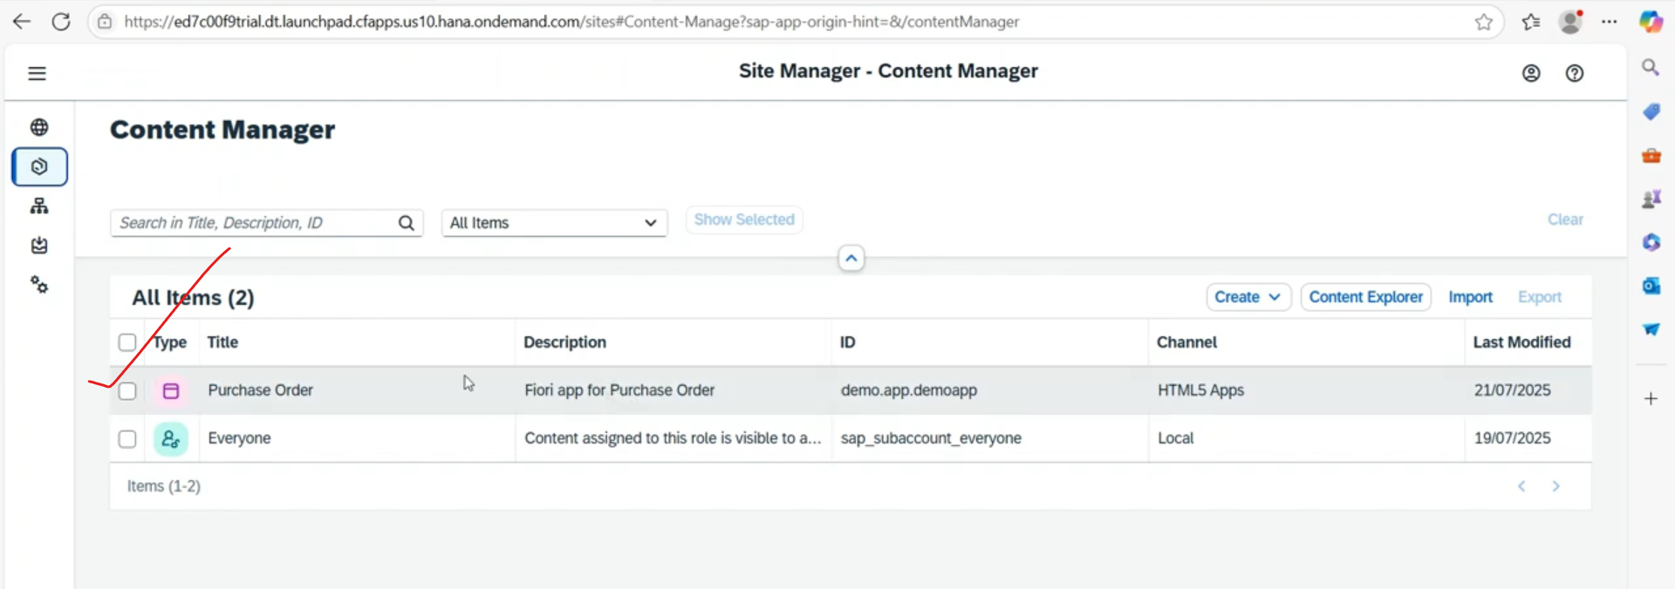

Added ..

* Create group under content manager. – to assign the app to group

Now create the group using purchase order applications.

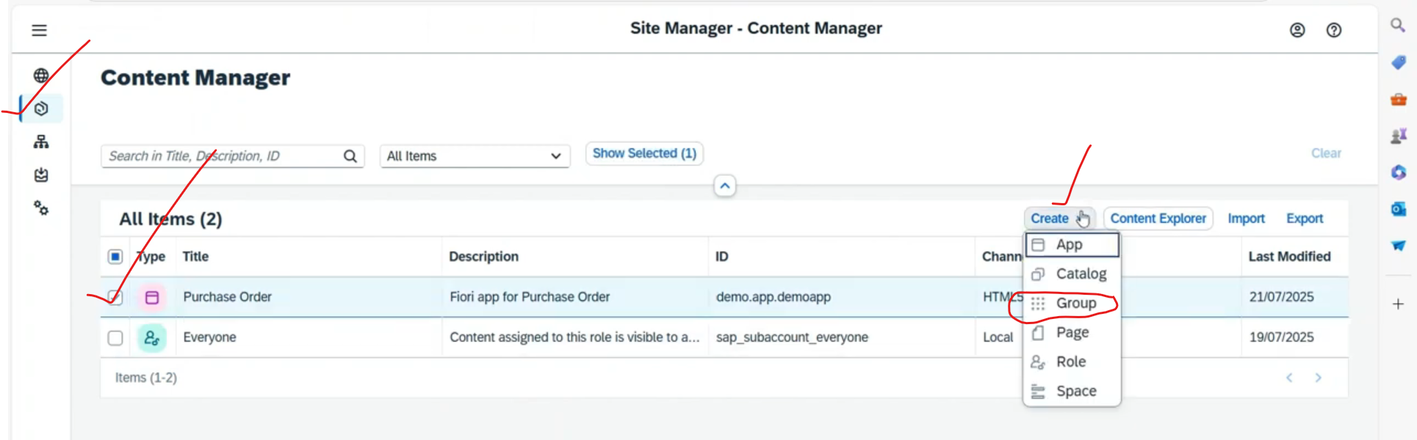

Next screen

Provide group name: in group title

Provide description

@group level you can able to see all the applications, you have to enable/bind to that group.

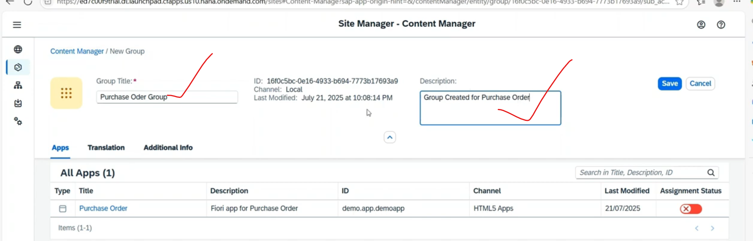

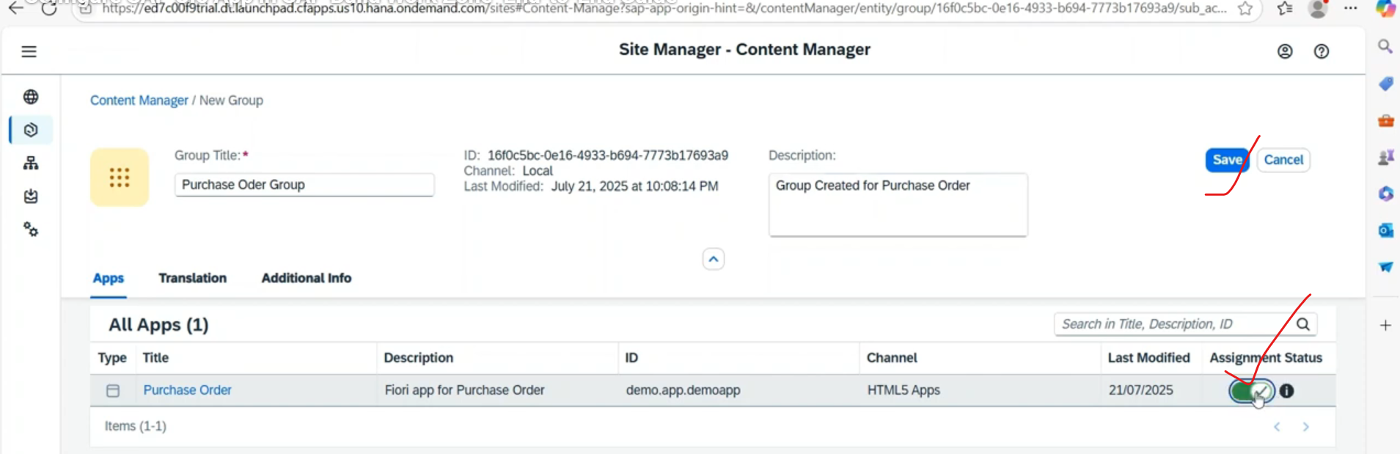

Click on save.

Now group has been created and assigned the applications to the group.

* Create a site -Now go to site directory tab and Site- is like a launchpad page.

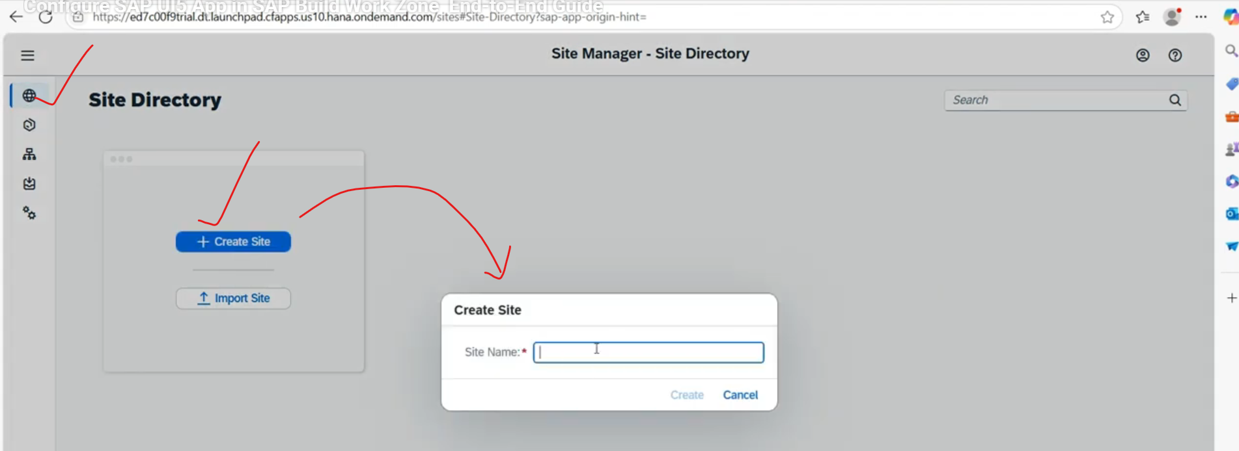

Site Name: Demo Launchpad

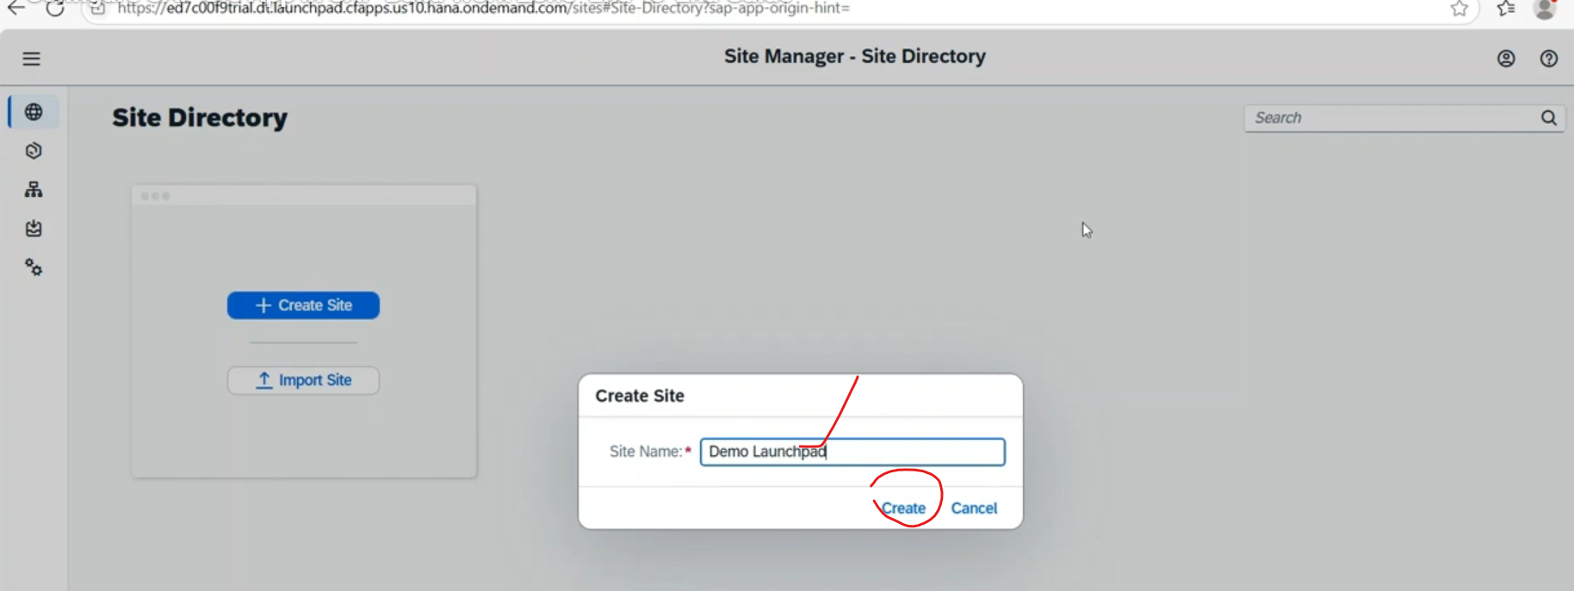

Click on create.

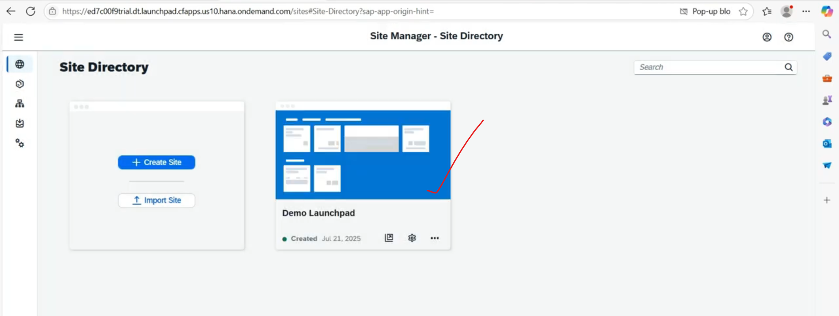

Site created successfully.

We can assign n- number of sites also.

Within these sites, we can add those applications, you have to add those group into this.

* In site we have three options

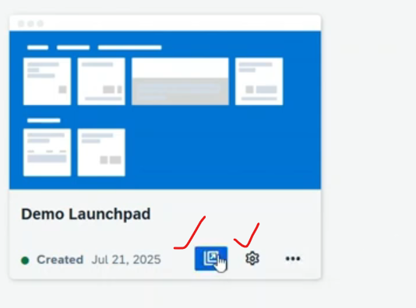

* + Go to the site.
  + Site settings.
* Site setings screen:
* 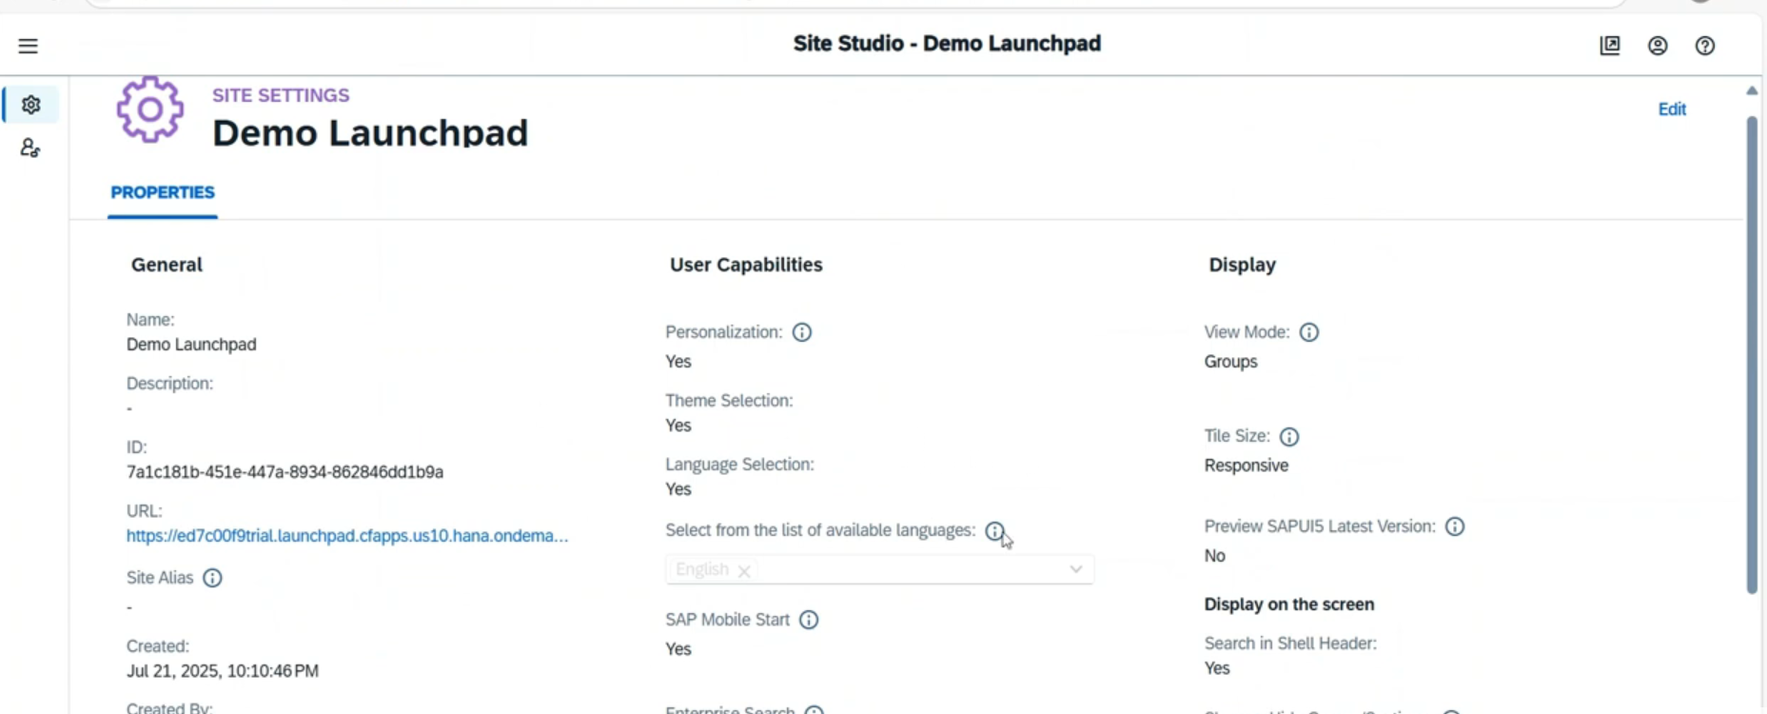
* Click on Goto the site 🡪 it will open the site in browser level with home screen.(Basically open the launchpad view with home screen)

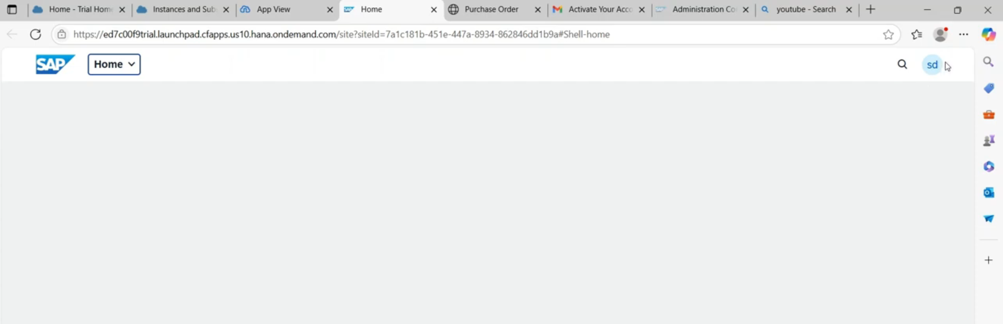

Now here purchase order application not present over here.

Till now we have created the group only but not assigned any role, once assign the role we can able to see the our tile..

To assign the role click on site settings on tile.



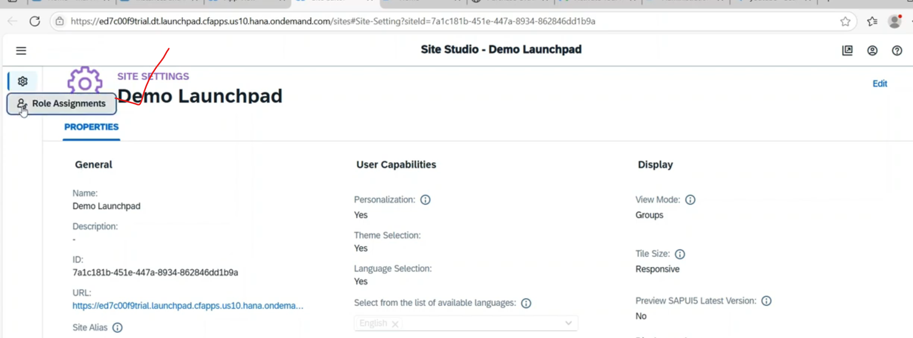

Click on role assignments.

You have to assign the site to a role, so that end user having the acces the to the role and he can able to see the tile in launch pad.

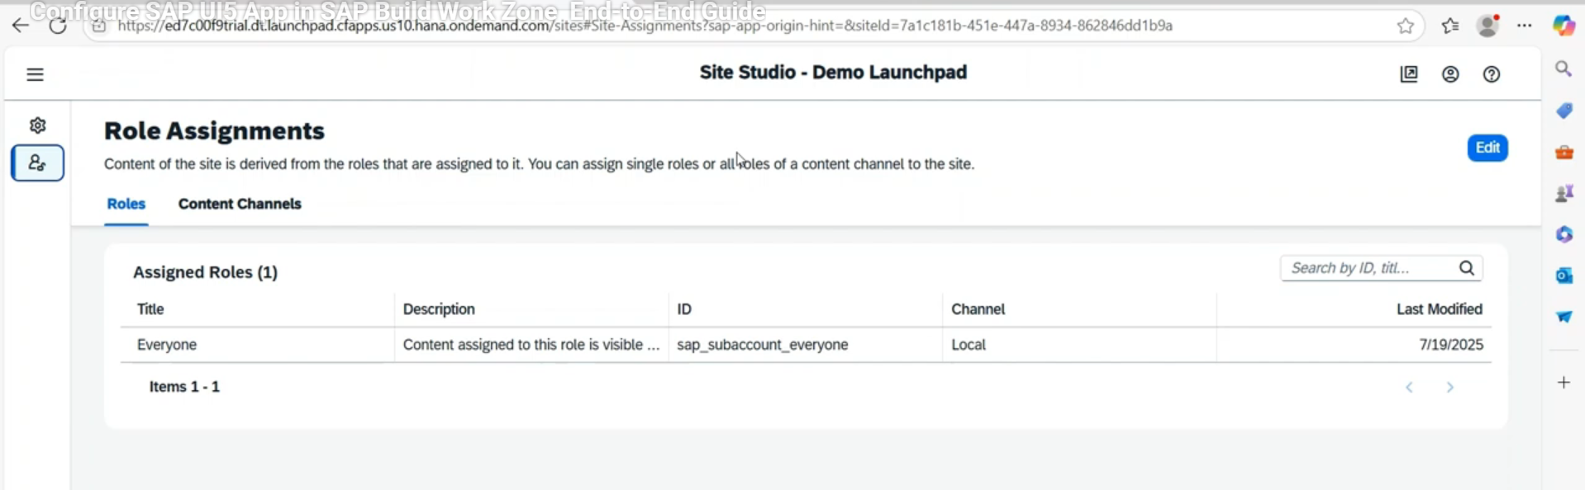

Here observed that by default role- every one role is assigned.

Now what we will do🡪 we will go to content manager page.

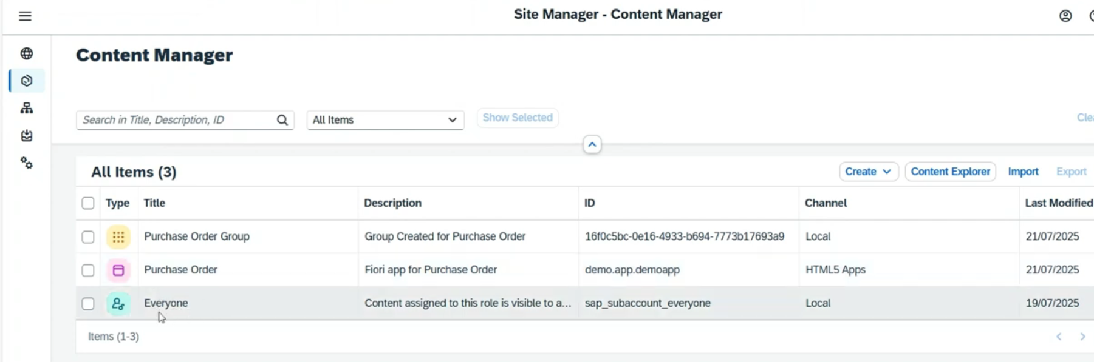

First assigned role-every one to application purchase order.

Select everyone role.. by default display mode - click on edit and enable the application.

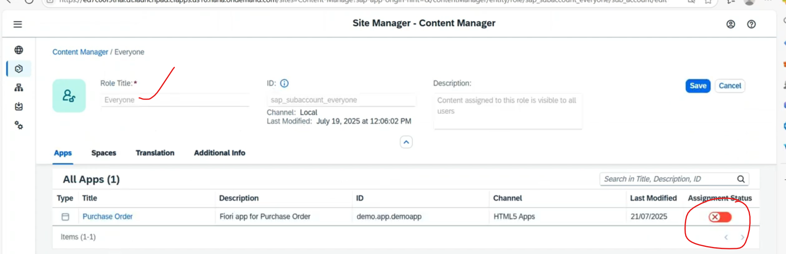

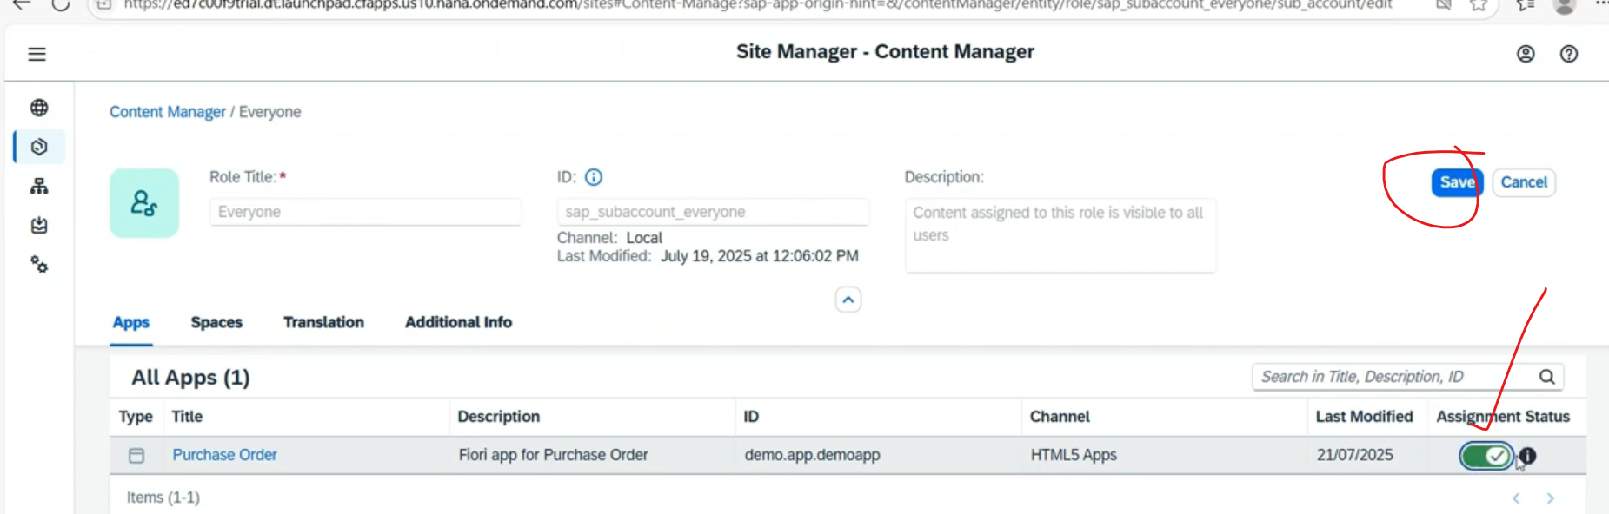

Click on save.

Now our application added to the every one role.

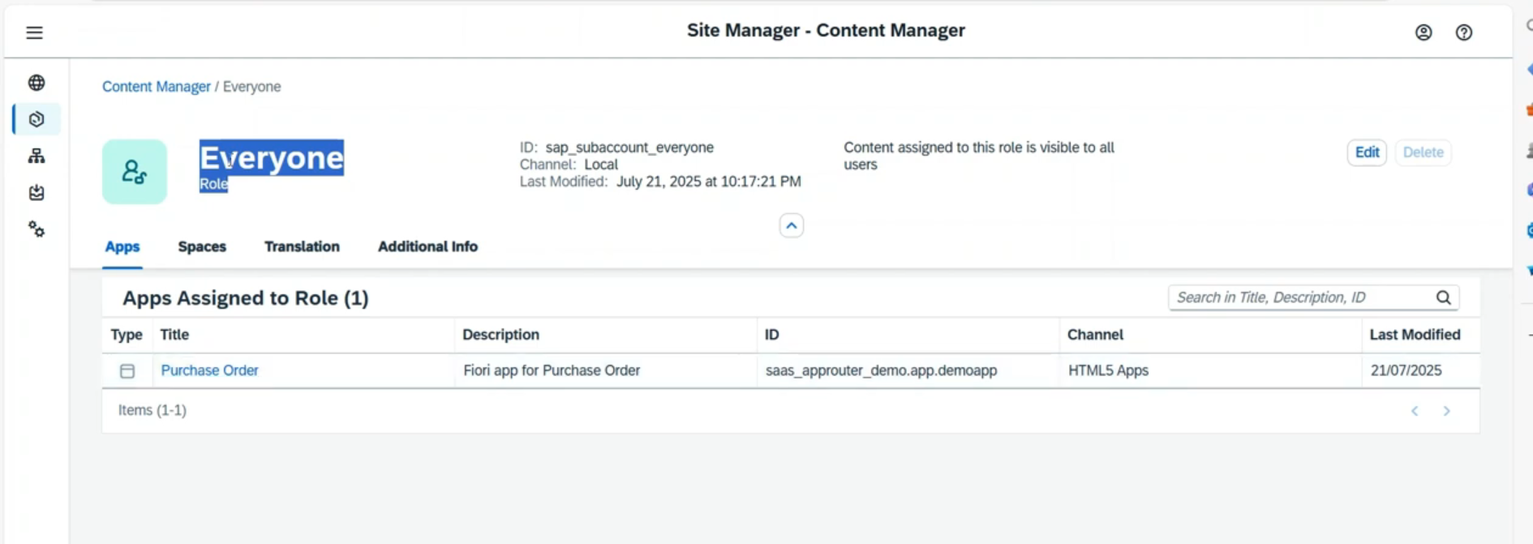

* Now go to site directory – on tile click on go to site button 🡪 it is redirecting to the fiori launchpad screen.
* 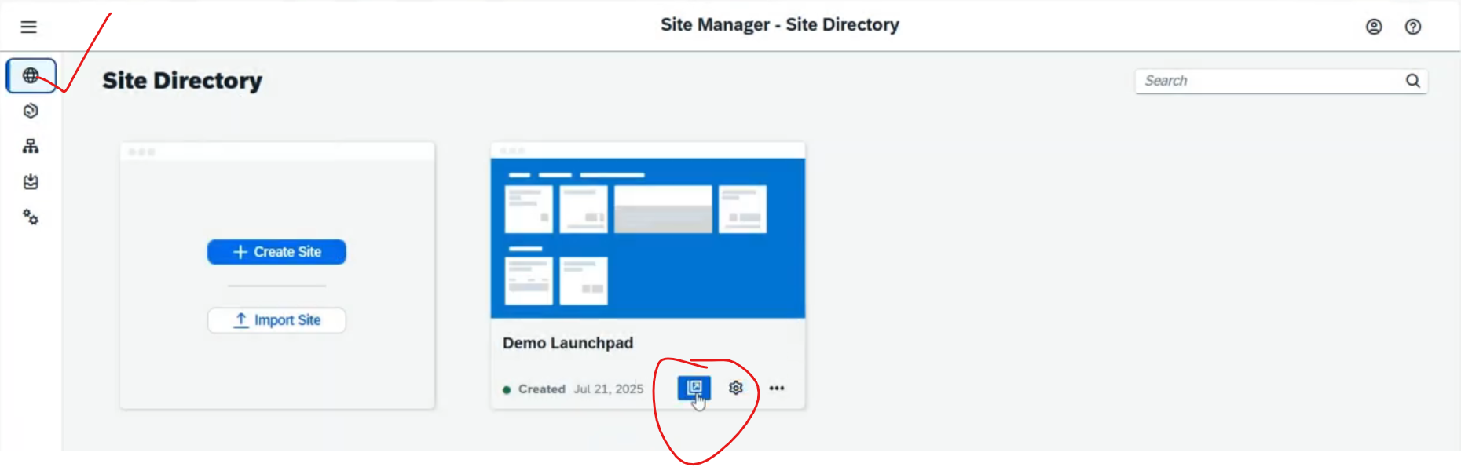
* 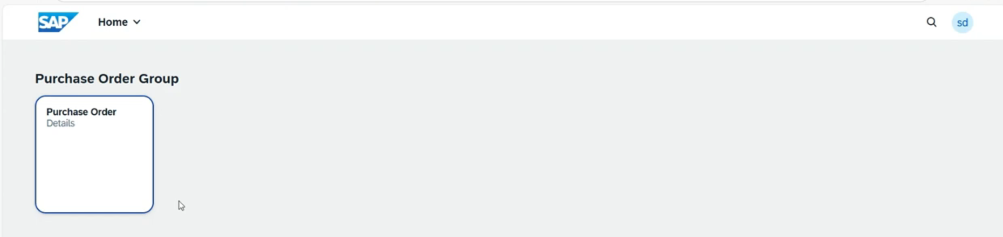
* Now we are able to see the our applications.
* Click on applications, we can able to see the data .

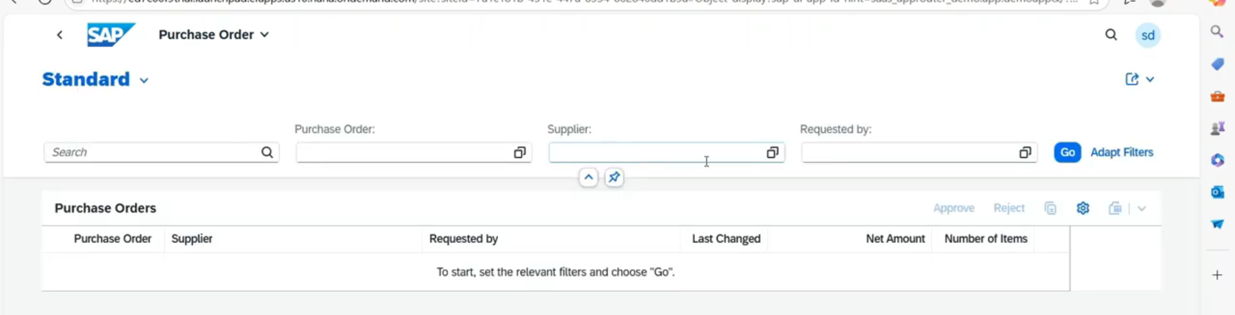

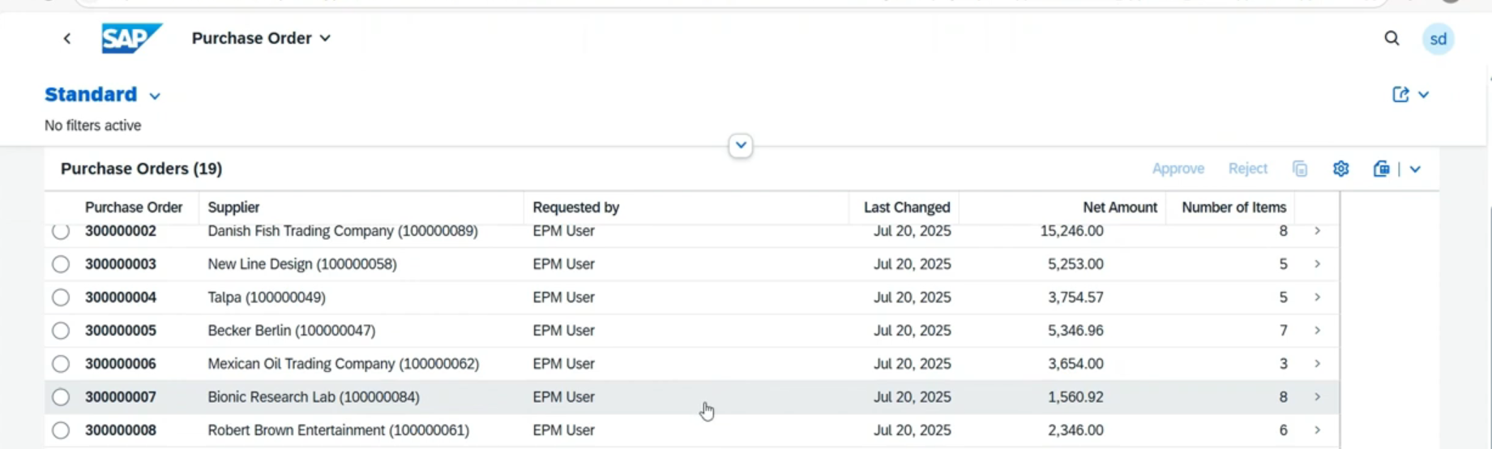

1. Create the new content provider 🡪 click New button and select the content provider.

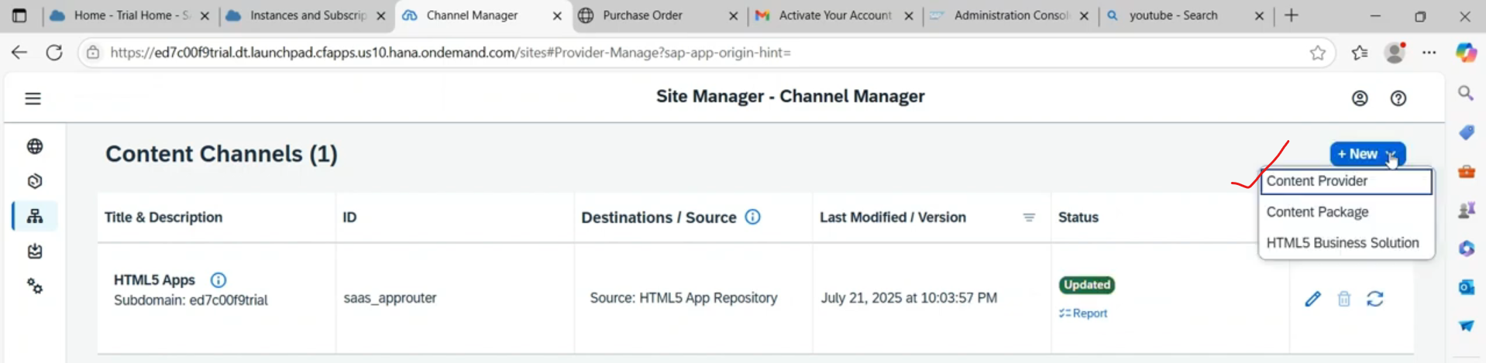

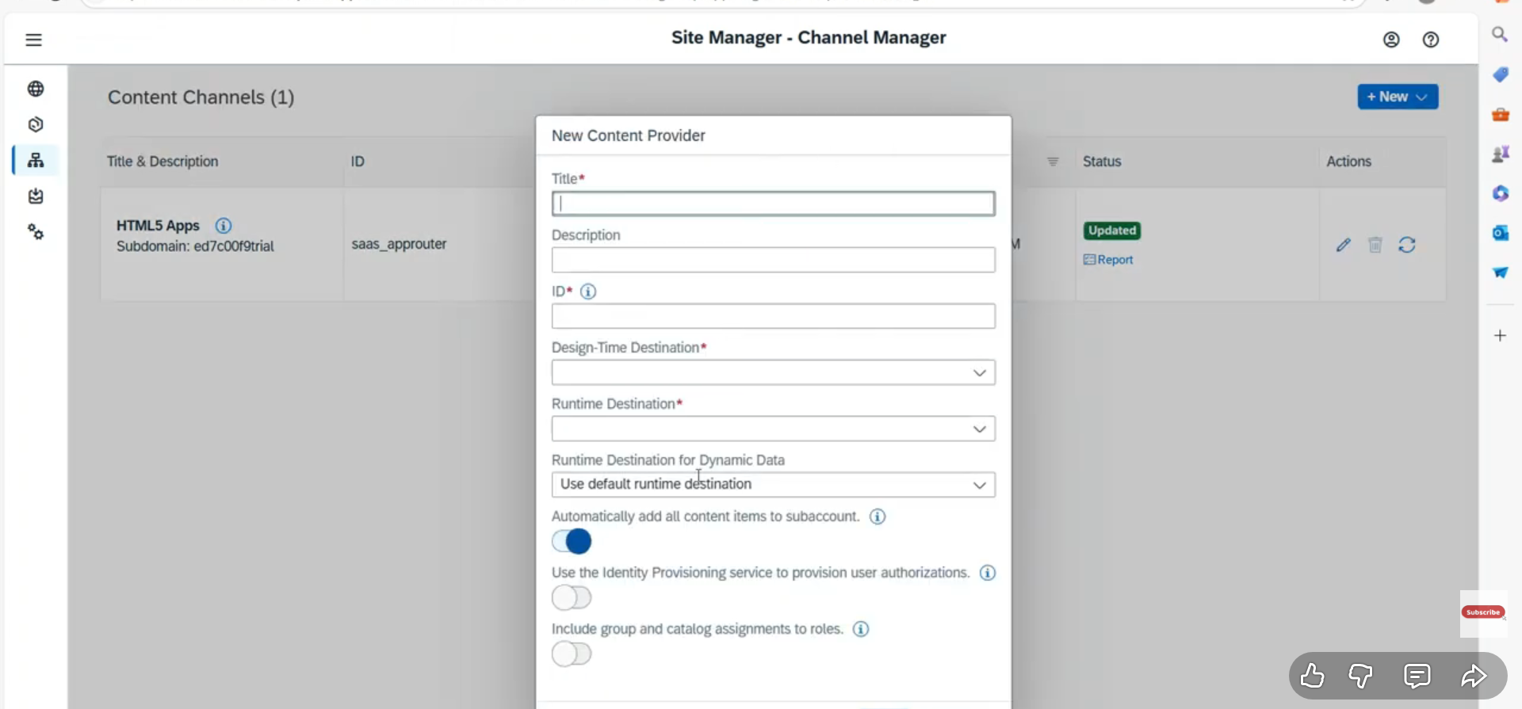

Content provider : mainly used for suppose you have deploy your apps into the on-premise system, later on you need to deploy it in build workzone in this case we can use content provider.

1. Launch pad id roles assigned to the user .

